**Laporan Praktikum**

**Pemrograman Web 1**

**Dosen pengampu : Yati Nurhayati S.Kom., M.Kom**



**Nama : Bayu Imantoro**

**NIM : 20230810089**

**Kelas : TINFC – 2023 – 04**

**Teknik Informatika**

**Fakultas Ilmu Komputer**

**Universitas Kuningan**

POSTEST

1. 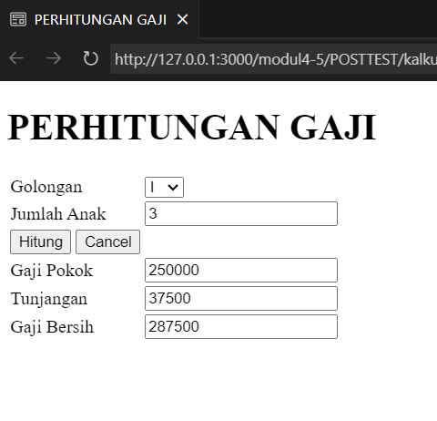

<!DOCTYPE html>

<html>

<head>

<title>PERHITUNGAN GAJI</title>

</head>

<body>

<h1>PERHITUNGAN GAJI</h1>

<form name="form1">

<table>

<tr>

<td>Golongan</td>

<td>

<select name="golongan">

<option value="I">I</option>

<option value="II">II</option>

<option value="III">III</option>

</select>

</td>

</tr>

<tr>

<td>Jumlah Anak</td>

<td><input type="number" name="anak" size="10" maxlength="10"></td>

</tr>

<tr>

<td>

<input type="button" name="hitung" value="Hitung" onClick="hitungGaji()">

<input type="reset" name="Batal" value="Cancel">

</td>

</tr>

<tr>

<td>Gaji Pokok</td>

<td><input type="text" name="gapok" readonly></td>

</tr>

<tr>

<td>Tunjangan</td>

<td><input type="text" name="tunjangan" readonly></td>

</tr>

<tr>

<td>Gaji Bersih</td>

<td><input type="text" name="gaji" readonly></td>

</tr>

</table>

</form>

<script>

function hitungGaji() {

var golongan = document.form1.golongan.value;

var jumlahAnak = parseInt(document.form1.anak.value);

var gajiPokok;

var persenTunjangan;

switch (golongan) {

case "I":

gajiPokok = 250000;

persenTunjangan = 0.05;

break;

case "II":

gajiPokok = 300000;

persenTunjangan = 0.1;

break;

case "III":

gajiPokok = 350000;

persenTunjangan = 0.15;

break;

}

//menghitung tunjangan dan gaji bersih

var tunjangan = (jumlahAnak * gajiPokok) * persenTunjangan;

var gajiBersih = gajiPokok + tunjangan;

//menampilkan hasil perhitungan

document.form1.gapok.value = gajiPokok;

document.form1.tunjangan.value = tunjangan;

document.form1.gaji.value = gajiBersih;

}

</script>

</body>

</html>

1. 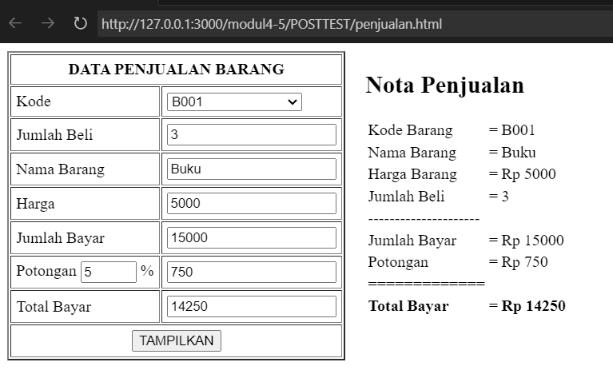

<!DOCTYPE html>

<html lang="id">

<head>

<meta charset="UTF-8">

<meta name="viewport" content="width=device-width, initial-scale=1.0">

<title>Penjualan Barang</title>

<script>

function updateBarang() {

const kodeBarang = document.getElementById("kode").value;

const namaBarang = document.getElementById("namaBarang");

const hargaBarang = document.getElementById("harga");

const barang = {

B001: { nama: "Buku", harga: 5000 },

B002: { nama: "Penggaris", harga: 1500 },

B003: { nama: "Pulpen", harga: 2000 }

};

if (barang[kodeBarang]) {

namaBarang.value = barang[kodeBarang].nama;

hargaBarang.value = barang[kodeBarang].harga;

} else {

namaBarang.value = "";

hargaBarang.value = "";

}

hitungTotal();

}

function hitungTotal() {

const harga = parseInt(document.getElementById("harga").value) || 0;

const jumlahBeli = parseInt(document.getElementById("jumlahBeli").value) || 0;

const jumlahBayar = harga * jumlahBeli;

let potonganPersen = 0;

if (jumlahBeli >= 0 && jumlahBeli <= 10) {

potonganPersen = 5;

} else if (jumlahBeli >= 11 && jumlahBeli <= 20) {

potonganPersen = 10;

} else if (jumlahBeli > 20) {

potonganPersen = 15;

}

const potongan = (potonganPersen / 100) * jumlahBayar;

const totalBayar = jumlahBayar - potongan;

document.getElementById("jumlahBayar").value = jumlahBayar;

document.getElementById("potongan").value = potongan;

document.getElementById("totalBayar").value = totalBayar;

document.getElementById("persenPotongan").value = potonganPersen;

}

function tampilkanNota() {

const kode = document.getElementById("kode").value;

const namaBarang = document.getElementById("namaBarang").value;

const hargaBarang = document.getElementById("harga").value;

const jumlahBeli = document.getElementById("jumlahBeli").value;

const jumlahBayar = document.getElementById("jumlahBayar").value;

const potongan = document.getElementById("potongan").value;

const totalBayar = document.getElementById("totalBayar").value;

document.getElementById("nota").innerHTML = `

<h2>Nota Penjualan</h2>

<table>

<tr><td>Kode Barang</td><td>=</td><td>${kode}</td></tr>

<tr><td>Nama Barang</td><td>=</td><td>${namaBarang}</td></tr>

<tr><td>Harga Barang</td><td>=</td><td>Rp ${hargaBarang}</td></tr>

<tr><td>Jumlah Beli</td><td>=</td><td>${jumlahBeli}</td></tr>

<tr><td>---------------------</td></tr>

<tr><td>Jumlah Bayar</td><td>=</td><td>Rp ${jumlahBayar}</td></tr>

<tr><td>Potongan</td><td>=</td><td>Rp ${potongan}</td></tr>

<tr><td>=============</td></tr>

<tr><td><strong>Total Bayar</strong></td><td>=</td><td><strong>Rp ${totalBayar}</strong></td></tr>

</table>

`;

}

</script>

<link rel="stylesheet" href="csspt2.css">

</head>

<body>

<div style="display: flex; gap: 20px; align-items: flex-start;">

<form name="form1">

<table border="2" cellpadding="5" cellspacing="2">

<tr>

<td colspan="2" align="center"><b>DATA PENJUALAN BARANG</b></td>

</tr>

<tr>

<td>Kode</td>

<td>

<select id="kode" onchange="updateBarang()">

<option value="">--Pilih Salah Satu--</option>

<option value="B001">B001</option>

<option value="B002">B002</option>

<option value="B003">B003</option>

</select>

</td>

</tr>

<tr>

<td>Jumlah Beli</td>

<td><input type="number" id="jumlahBeli" oninput="hitungTotal()" value="0"></td>

</tr>

<tr>

<td>Nama Barang</td>

<td><input type="text" id="namaBarang" readonly></td>

</tr>

<tr>

<td>Harga</td>

<td><input type="text" id="harga" readonly></td>

</tr>

<tr>

<td>Jumlah Bayar</td>

<td><input type="text" id="jumlahBayar" readonly></td>

</tr>

<tr>

<td>Potongan <input type="text" id="persenPotongan" readonly size="3"> %</td>

<td><input type="text" id="potongan" readonly></td>

</tr>

<tr>

<td>Total Bayar</td>

<td><input type="text" id="totalBayar" readonly></td>

</tr>

<tr>

<td colspan="2" align="center">

<input type="button" value="TAMPILKAN" onclick="tampilkanNota()">

</td>

</tr>

</table>

</form>

<div id="nota" style="width: auto;">

</div>

</div>

</body>

</html>